**ASSIGNMENT 7.2**

**Problem description:**

We have a dataset of sales of different TV sets across different locations. Records look like: Samsung | Optima | 14 | Madhya Pradesh | 132401 | 14200

The fields are arranged like:

Company Name | Product Name | Size in inches | State | Pin Code | Price Sales_TV: https://github.com/prateekATacadgild/DatasetsForCognizant/blob/master/sales_differentTV.txt Sales of different TV

**Problems:**

* Task 6: Modify Sales of different TV Task 3 (refer session 5, assignment 2) to take advantage of Combiner. Sales of different TV

* Task 7: Write a Mapreduce program to view the total sales for each product for every Company corresponding to each size. Make sure that all records for a single company goes to a single reducer and inside every reducer, keys must be sorted in descending order of the size. You may write a custom WritableComparable for this purpose.

**Task 6:**

Modify Sales of different TV Task 3 (refer session 5, assignment 2) to take advantage of Combiner. Sales of different TV

**Program:**







**Output:**

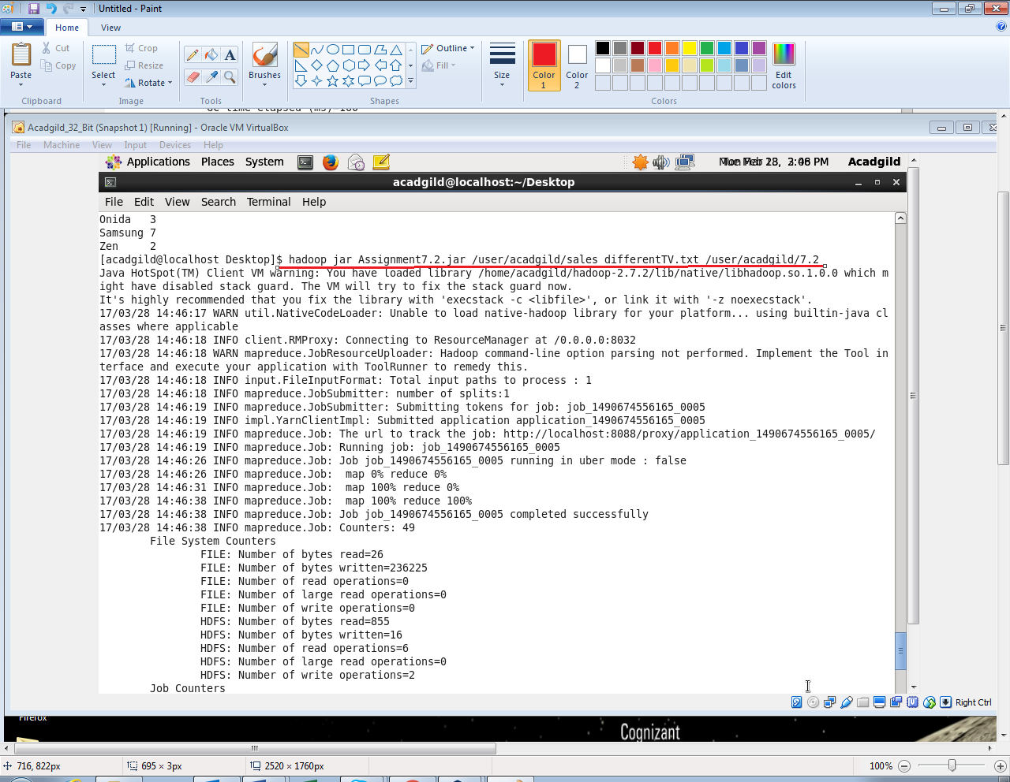

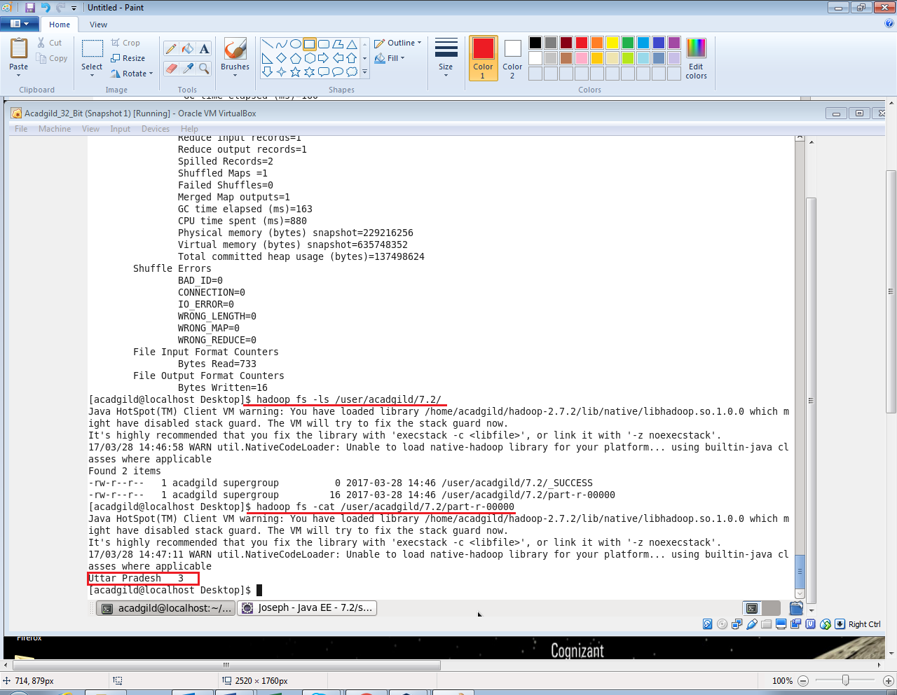

**Task 7:**

Write a Mapreduce program to view the total sales for each product for every Company corresponding to each size. Make sure that all records for a single company goes to a single reducer and inside every reducer, keys must be sorted in descending order of the size. You may write a custom WritableComparable for this purpose.

**Program:**





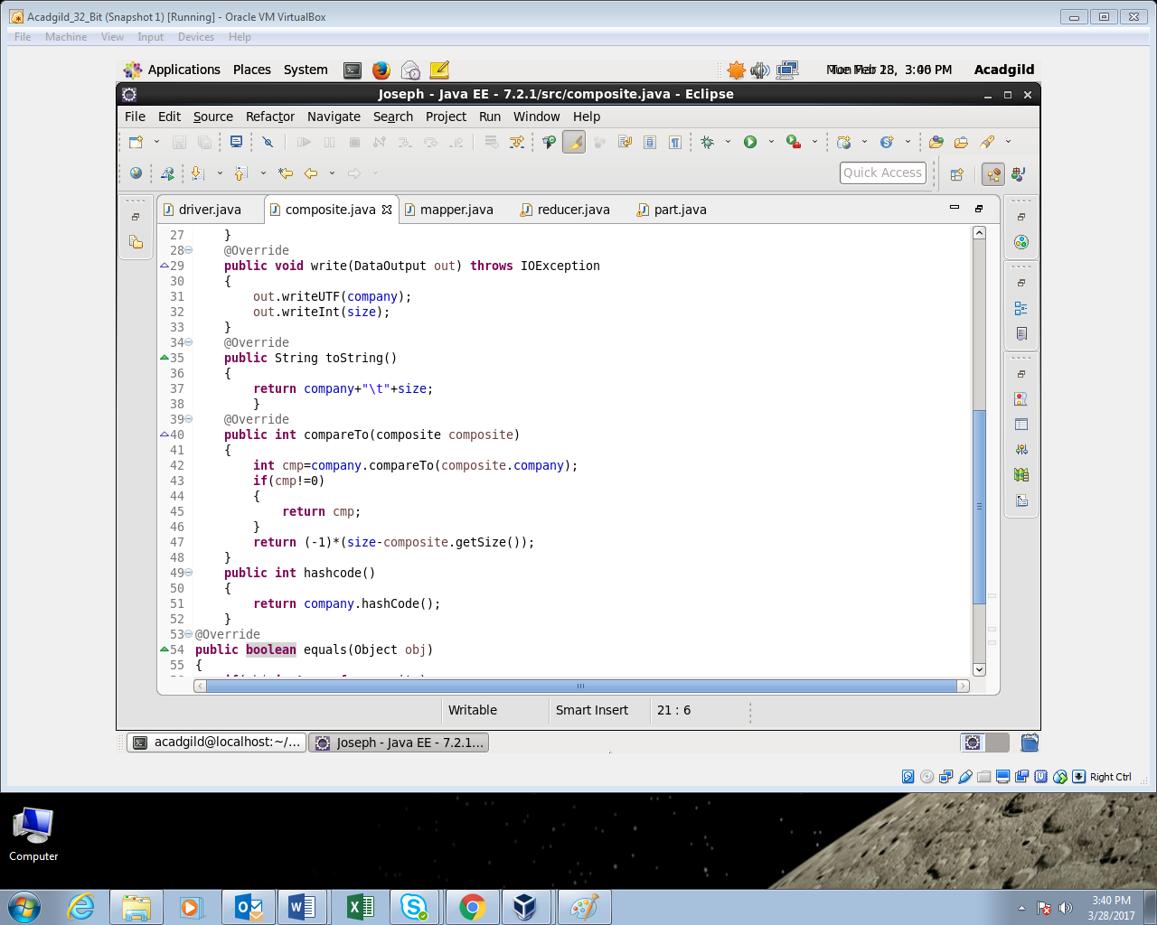

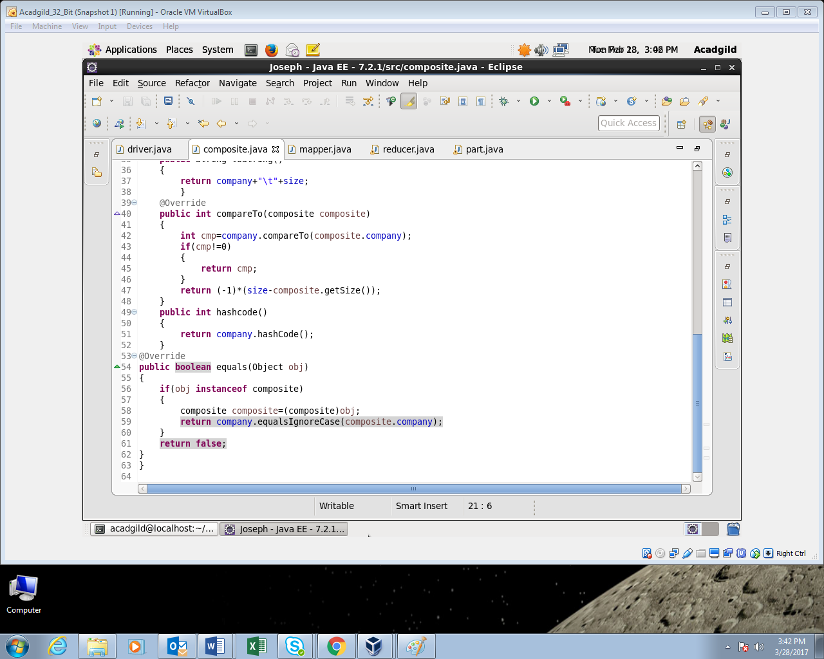

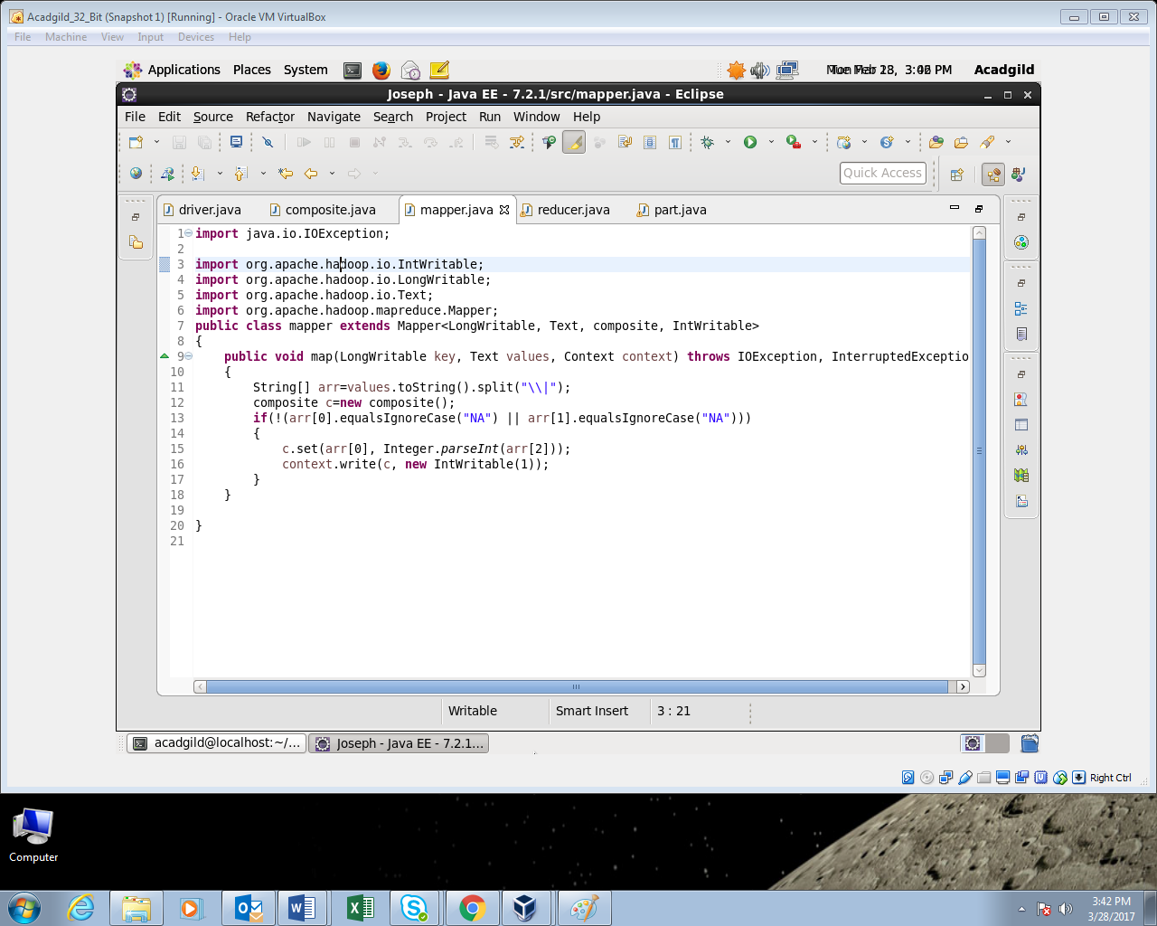

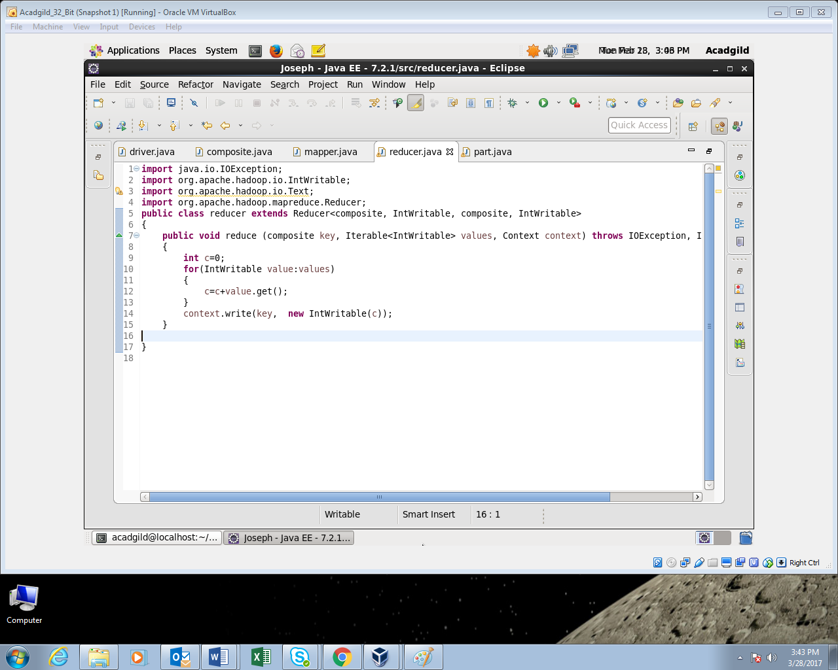

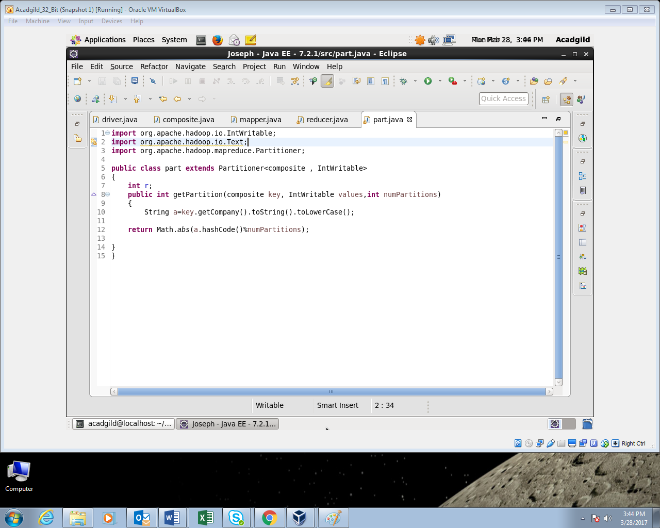

**Output:**

